
INSTALLATION

Microsoft Dynamics Snap

How to Install Snap-ins

Installation Guide

Microsoft Dynamics Snap for Business Data Lookup
Microsoft Dynamics Snap for Custom Report Generator
Microsoft Dynamics Snap for Customer Journal

Technical Pre-release Version 1.0 for Microsoft Dynamics TM CRM 3.0 / 2007 Microsoft® Office system

February 10, 2007

Microsoft Dynamics Snap Sandbox

Table of Contents
INTRODUCTION 3
SYSTEM REQUIREMENTS 4
Pre-Requisites 4
INSTALLATION 5
REPAIR 6
UNINSTALL 7
SILENT INSTALL 8
LAUNCH THE SNAP 9

INTRODUCTION
Microsoft Dynamics Snap is an offering of applications that enable Information Workers to interact with Microsoft Dynamics information from within Microsoft Office applications.
The Phase 1 and 1.5 components of this program, which were made available in Feb 2006 and May 2006, worked with Microsoft Dynamics CRM 3.0 data sources and other custom controls and assemblies created for Microsoft Office Professional 2003.
The Phase 2 showcases integration between Microsoft Dynamics CRM 3.0 and the 2007 Microsoft Office system. Following is the list of snap-ins provided in Phase 2, which can be installed using this setup:
- Business Data Lookup Snap-in
- Customer Journal Snap-in
- Custom Report Generator Snap-in

SYSTEM REQUIREMENTS

Pre-Requisites

Local System
- At least 5 MB of disk space must be available on the local machine installation location.
- The installation files, including CRMWave2setup.exe, must be copied on your local machine. Do not install from the download site or from a network share directly
- User should be the administrator of the local machine

Microsoft Office 2007
- Microsoft Office 2007 should be installed, along with all the latest updates
- Microsoft Office Word, Microsoft Office Excel, Microsoft Office Outlook and Microsoft Office InfoPath should have been run at least once on the local machine
- Microsoft Office should be closed throughout the duration of setup

Microsoft Dynamics CRM 3.0
- The user must have permissions and access to the Microsoft Dynamics CRM 3.0 server

Framework and Runtime
- Microsoft .NET Framework 2.0 should be installed on the system
- Microsoft VSTO 2005 SE Runtime should be installed on the system

Miscellaneous
- Pre-release versions of all snap-ins should be uninstalled before starting installation
- The snap-ins have been tested on Windows Vista Enterprise, Windows XP Professional, Windows Server 2003 editions of Windows.
- The snap-ins have been tested on Enterprise and Standard editions of 2007 Microsoft Office system.

INSTALLATION

Microsoft Dynamics Snap can be downloaded directly from the Microsoft Dynamics Snap site and needs to be saved to a local machine for installation at a later time.
The following procedure will install a Microsoft Dynamics Snap application on the local machine:
- Close all Microsoft Office applications
- Run CRMWave2Setup.exe
- The License Agreement dialog box appears.
- After reading the License Agreement choose ‘I accept this license agreement’ , click on I Accept
- A dialog box will appear asking for scenarios to install. Select the snap-ins you wish to install
- In the subsequent dialog box enter the name of the CRM Server http://crmserverurl:portnumber and click OK
[It is strongly recommend making the CRM web services available only via https. In such a case the value entered would look like https://crmserverurl:portnumber]
- Type the location where you want to save this snap-in. The location can be retrieved by clicking on the Browse button. Once this step is completed, click Next
- The ‘Ready to Install’ dialog box appear, click Install
- The chosen snap-ins will be installed
- Once the installation is complete the ‘Installation Complete’ dialog box appears. Click Close
- Run GiveTrusttoSnapVSTO.cmd
[For Vista, run the above command in administrator mode]
- Open Microsoft Office applications

Note:
When CRMWave2Setup.exe is run, if you are taken directly to the repair/ remove screen, it means that one of the scenarios is already installed in your machine. To install a new scenario,
- Select Uninstall, click Next. This removes all the previously installed scenarios
- Run CRMWave2Setup.exe
- Start install process and choose scenarios as required

REPAIR

The following procedure will repair Microsoft Dynamics Snap-ins
- Run CRMWave2Setup.exe
- Select Repair, and click Next
-- OR --
- On the Start menu, click Control Panel, and then click Add or Remove Programs.
- Select Microsoft Dynamics Snap for Microsoft Dynamics CRM 3.0 and then click Change. The Microsoft Dynamics Snap-ins for Microsoft Dynamics CRM Setup window will open
- Select Repair, and click Next

This will begin the repair of the Microsoft Dynamics Snap-ins

UNINSTALL

The following procedure will uninstall Microsoft Dynamics Snap-ins
- Run CRMWave2Setup.exe
- Select Uninstall, and click Next
-- OR –
- On the Start menu, click Control Panel, and then click Add or Remove Programs.
- Select Microsoft Dynamics Snap-ins for Microsoft Dynamics CRM 3.0 and then click Remove.
- Select Uninstall, and click Next
This will remove all the program files and services but will not remove any dependent components installed during setup.

SILENT INSTALL

The following procedure will install Microsoft Dynamics Snap-ins from the command line
- Close all Microsoft Office applications
- Open CRMConfig.xml
- Change the name of the CRM Server
- Change the install directory if needed
- Choose the snaps you want to install, (follow the instructions in the config file)
- Run CRMwave2setup.exe /q /L <logfilename> /config CRMConfig.xml from the command line
- LogFileName user can give as “path\filename.log”
- Run GiveTrusttoSnapVSTO.cmd
[For Vista, run the above command in run as administrator mode]
- Open Microsoft Office applications

LAUNCH THE SNAP

To launch the snaps
- Open Microsoft Outlook, Word, Excel and click on the Snap menu bar. The BDL for CRM 3.0 section will be visible in the Snap ribbon.
- Open Sales Dashboard and Forecasting.xlsx workbook in the Example Reports folder installed along with the Snap. The CRG for CRM 3.0 section will be visible in the Snap ribbon.
[Default Installation Path would be Program Files/Microsoft Dynamics Snap/CRM 3.0/ Custom Report Generator/Example Reports/ ]
- Open Customer Journal Form Template for CRM.xsn in the install directory/Customer Journal

Note
If add-in is not appearing after installing, you will need to enable the Microsoft Dynamics Snap add-ins. Follow the steps given below to do this.
- Click Customize Quick Access Toolbar
- Choose More Commands …
- Go to the Add-Ins menu, select COM add-ins in the Manage drop down and click Go.
- Check the checkboxes next to the Microsoft Dynamics Snap Add-ins. Click Ok and restart Office application.

If the Infopath form shows an error on opening, close the form and follow the steps below.
- Go to Add-Remove Programs, and click Change against Microsoft Office 2007.
- The maintenance screen will be launched.
- Select Add- Remove features and click continue.
- In the Installations Options tab, click arrow beside Microsoft Office InfoPath, and select Run all from My Computer, and click Continue.
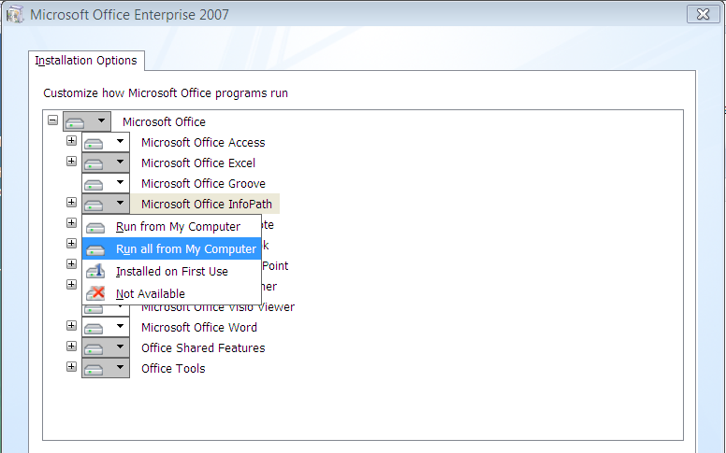

Microsoft Dynamics is a line of integrated, adaptable business management solutions that enables you and your people to make business decisions with greater confidence. Microsoft Dynamics works like and with familiar Microsoft software, automating and streamlining financial, customer relationship and supply chain processes in a way that helps you drive business success.

www.microsoft.com/dynamics

The information contained in this document represents the current view of Microsoft Corporation on the issues discussed as of the date of publication. Because Microsoft must respond to changing market conditions, this document should not be interpreted to be a commitment on the part of Microsoft, and Microsoft cannot guarantee the accuracy of any information presented after the date of publication.
This White Paper is for informational purposes only. MICROSOFT MAKES NO WARRANTIES, EXPRESS, IMPLIED, OR STATUTORY, AS TO THE INFORMATION IN THIS DOCUMENT.
Complying with all applicable copyright laws is the responsibility of the user. Without limiting the rights under copyright, no part of this document may be reproduced, stored in or introduced into a retrieval system, or transmitted in any form or by any means (electronic, mechanical, photocopying, recording, or otherwise), or for any purpose, without the express written permission of Microsoft Corporation.
Microsoft may have patents, patent applications, trademarks, copyrights, or other intellectual property rights covering subject matter in this document. Except as expressly provided in any written license agreement from Microsoft, the furnishing of this document does not give you any license to these patents, trademarks, copyrights, or other intellectual property.

© 2006 Microsoft Corporation. All rights reserved.
Microsoft, the Microsoft Dynamics Logo, 2007 Microsoft Office System, BizTalk, Dexterity, FRx, Microsoft Dynamics, SharePoint, Visual Basic, Visual C++, Visual SourceSafe, Visual Studio, Windows, and Windows Server are either registered trademarks or trademarks of Microsoft Corporation, FRx Software Corporation, or Microsoft Business Solutions ApS in the United States and/or other countries. Microsoft Business Solutions ApS and FRx Software Corporation are subsidiaries of Microsoft Corporation.

